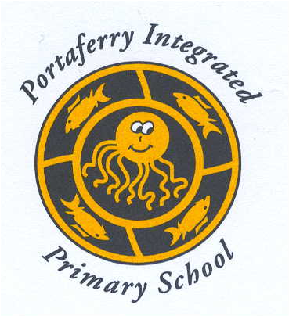

14th October 2020
Dear Parents

Today, the Executive has announced that schools and other education settings will have the half-term holiday break extended from 19 to 30 October.

Education settings will be closed to all pupils during these two weeks including for vulnerable children and children of key workers. Schools and other settings will reopen on Monday, 2 November.

As this is an extension of the half-term break, it is not intended to be used for remote online learning. However, as the children have made such great progress from the end of August, we will be sending some Numeracy and Literacy work home for next week. We strongly encourage the children to complete this and to return it to the teacher on the first day back.

During the week beginning 19 October direct payments will be made to pupils in receipt of Free School Meals.
Should you have any queries, please contact Mrs Allen by email nallen400@c2kni.net or Mr McKeown mmckeown925@c2kni.net

Best wishes

NICOLA ALLEN
P1 TEACHER

